**EE 352 - Communication Systems 1**

Hardware Laboratory Report-1

**Amplitude Modulation and Demodulation**

Ferhat Böcek : 260206070

Onur Bodurer : 260206072

Şule Zeynep Parlat : 260206062

**Abstract**

In this experiment, the aim of this experiment is analyzing the Conventional Double Sideband Amplitude Modulation (DSB AM).

In the Conventional AM, the carrier signal is suppressed in an envelope that is formed with a message signal. Then, with the envelope detector, the message signal can be obtained according to the modulation factor. The transmitted signal can be expressed as;

transmitted signal s(t)

s(t) = Ac[1 + ka ∗ m(t)] ∗ cos(2 ∗ fc ∗ t) → ka is amplitude sensitivity

m(t) = Am ∗ cos(2 ∗ π ∗ fm ∗ t)

m(t): message signal

c(t)= Ac ∗ cos(2 ∗ π ∗ fc ∗ t)

c(t) : carrier signal

s(t) = Ac[1 + ka ∗ Am ∗ cos(2 ∗ π ∗ fm ∗ t)] ∗ cos(2 ∗ fc ∗ t)

μ = ka ∗ Am

The modulation factor is the ratio of the change in the amplitude of the carrier wave to the amplitude of the unmodulated carrier wave after the modulation process.

There are three case according to magnitude of the modulation factor which are;

* | ka ∗ m(t) | < 1 (under modulation)
* | ka ∗ m(t) | > 1 (over modulation)
* | ka ∗ m(t) | = 1 (perfect modulation)

**Introduction**:

Amplitude modulation (AM) is one of the most widely used communication types and technologies in electronics and communication systems. It is a modulation method used to transmit the message signal over long distances with radio waves. In amplitude modulation, the change in the amplitude of the message signal proportionally changes the amplitude of the carrier signal.

Demodulation is a process to obtain the original message signal from the carrier signal.

An amplitude modulation signal encodes information into the carrier wave by changing its amplitude in proportion to the analog signal to be sent. There are two methods used to demodulate AM signals.

One of the oldest demodulation techniques is the envelope detector. It is a simple demodulation method that does not require a consistent demodulator. It consists of an envelope detector, which can be rectified by passing the current in only one direction, or a low-pass filter that amplifies half of the received signal relative to the other.

The product detector multiplies the incoming modulated signal with the signal of an oscillator with the same frequency and phase as the carrier signal, and filtering is accomplished. After filtering, the original signal is obtained.

In this week's hardware lab experiment, we set up a modulation circuit using MC1496 for the modulation process. We generated two signals, message and carrier. Carrier signal 1 Vpp and 500kHz, message signal 0.4 Vpp and 200Hz. We used the trimpot -potentiometer- to change the modulation range. In the second part, we performed the demodulation process by installing a demodulator in order to receive the message signal from the modulated signal. The demodulator was a filter circuit with an envelope detector. We also observed how the circuit should be set up and how the signal changes depending on the modulation index (μ).

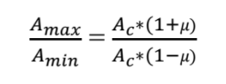

the modulation factor μ can be calculated as

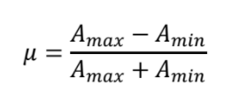

To prevent the overlap, the modulation factor should be less than or equal to 1.

**Experimental Procedure**

**Part 1 Modulation**

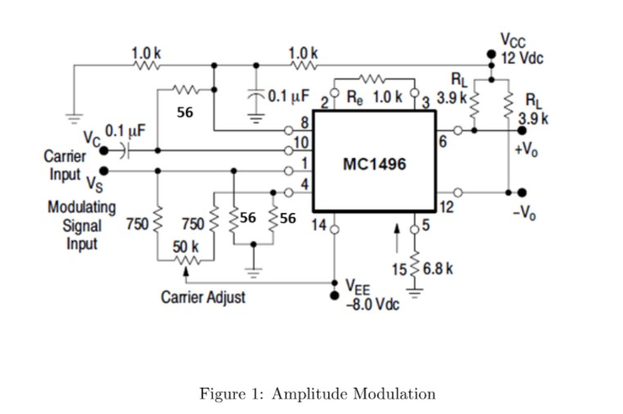

**Figure 1:** Amplitude Modulation Circuit**.**

In the first phase of this week's AM modulation demodulation experiment, after we set up our modulation circuit, we generated the message signal and the carrier signal with a signal generator device. We connected the carrier signal to the 10th pin (Vc) of the MC1496 IC, so this line became our carrier signal input. By connecting the message signal to be modulated to the 1st leg of the IC, we completed this line as a message signal input. By taking the outputs of the IC from the 6th and 12th legs, we tried to obtain our amplitude modulated signal output from here. We set the message signal to 0.4 Vpp, 200 Hz and the carrier signal to 1 Vpp, 500kHz.

In the experiment, 1xDC power supply, 1xOscilloscope, 2xFunction Generator,MC1496 IC, 3x56Ω, 2x750Ω, 2x3.9kΩ, 3x1kΩ, 1x6.8kΩ, 1x5.1kΩ Resistors, 1x50kΩ potentiometer, 3x100pF capacitors and 1x 1N4148 diode are used. There is pin connection about MC1496 IC;

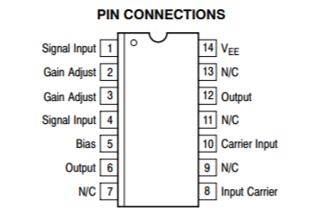

**Figure 2:** MC1496’s Pin Connections.

**Part 2 Demodulation**

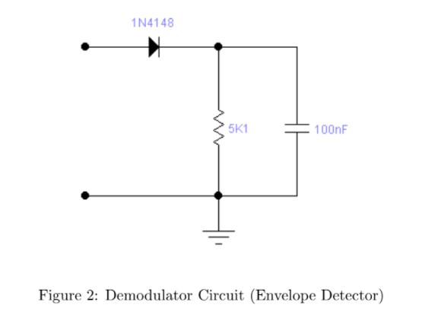

**Figure 3:** Demodulator Circuit (Envelope Detector)

For the demodulation process, there must be an additional circuit that we set up to receive the information signal from the carrier signal. This circuit consists of a diode (1N4148), a resistor (5k1) and a capacitor (100nF). We use diode to detect only part of the envelope and filter the diode output using capacitor and resistor. In this section, we combine the output of our modulation circuit with the demodulation input. Thus, we can compare the message signal with the modulated signal.

In the first part of the experiment, we aimed to change the modulation index using a potentiometer. Therefore, we observed different signals with the change in potentiometer resistance.

**Results and Discussion:**

In this section, we gradually changed the potentiometer resistance in order to determine the modulation indexes. Thus, we detected modulated signals of different amplitudes on the oscilloscope screen and separated them into modulation types.

m(t) = Am.cos(2πfmt) c(t)=Ac.cos(2πfct)

fm = 200Hz, Am = 0,4v fc = 500KHz, Ac =1v

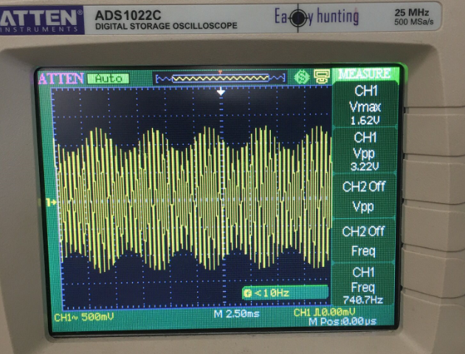

**Figure 4:** For μ<1, The waveform of the modulated signal is

Carrier Amplitude is less than Message Amplitude

Type of the modulation is undermodulated.

Amax = 1.5 V and Amin = 0.9 V. Then, calculated μ is

1.5 V - 0.9 V

μ = —–––––––––––– = 0.25

1.5 V + 0.9 V

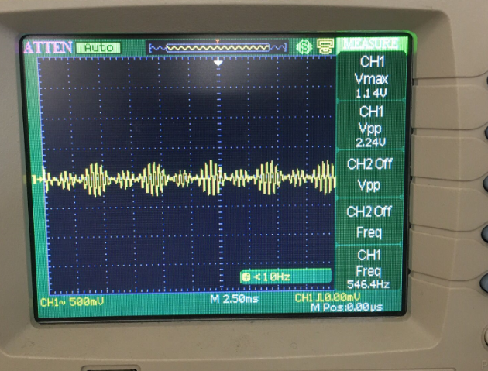

**Figure 5:** For μ>1, The waveform of the modulated signal is

Amax = 0.21 V and Amin = -0.13 V. Then, calculated μ is

0.21 V + 0.13 V

μ = —–––––––––––– = 4.25 **// Değerleri rastgele girdim düzeltilecek**

0.21 V - 0.13 V

Type of the modulation is overmodulated. There is envelope distortion due to

overmodulation.

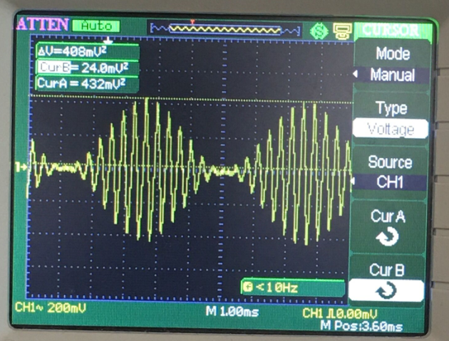

**Figure 6:** For μ=1, The waveform of the modulated signal is

Amax = 0.432 V and Amin = 0.024 V. Then, calculated μ is

Type of the modulation is critical modulated.

0.432 V + 0.024 V

μ = —–––––––––––– = 1.11

0.432 V - 0.024 V

In critical modulation, the message signal is preserved and does not lose its form. Thus, the modulated message signal can be recovered using the envelope detector without any degradation.

**Demodulated Signal:**

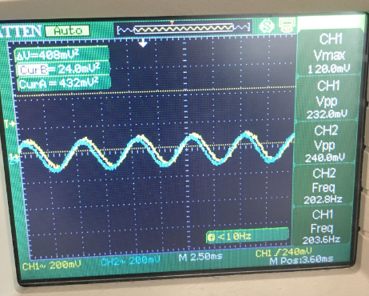

The yellow waveform is demodulated signal and the blue waveform is a modulated signal.

In this section, our aim was to take our modulated message signal from the carrier signal and to obtain the message signal again. In this process, we have built a circuit containing a diode and a low-pass filter. This circuit is called envelope detector and it demodulates our modulated signal. As seen on the oscilloscope screen, there is very little phase difference between the input signal and the demodulated signal.

There is also a difference due to the filtering process. The signal passes the diode signal in the positive cycle and the capacitance value of the capacitor affects the charge and discharge times and the current. The resistor value also affects the fluctuations in the output signal.

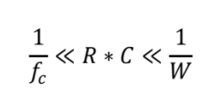

Discharge time interval and limitation

In this part, fc is the frequency of the carrier signal and the bandwidth of the message signal is W.

**Conclusion**

In this experiment, we set up AM modulation and demodulation with the MC1496 integrated circuit and analyzed its modulation after switching on our carrier and message signals. When the system is in modulation state, the value of the modulation index affects the output signal. While our potentiometer value was 50kΩ, we observed our modulation index as approximately less than 1. In addition, if the Modulation index is less than 1 and greater than 0, the modulation takes place perfectly. We lowered the resistance value of our potentiometer to observe the effect of the modulation index. If the modulation index is greater than 1, there will be some distortion and this will cause overmodulation. Also, overmodulation happens when the modulation index is greater than 1. We observed that all frequency and voltage values changed. As a result, we observed that there is overmodulation after the potentiometer reaches a certain value.

The demodulated output signal appears similar to our original message signal after demodulation. The diode in the demodulator prevents the negative component of the signal from passing - a diode and low pass filter-; after the capacitor reaches the greatest value, it slowly discharges through the load resistor. The voltage rises again after the positive cycle. The envelope detector changes the value of its RC from 1/fc to 1/W. Our output signal has some distortion. This deterioration happened as a result of the RC value. If we increase the value of the capacitor, our decline will be slower and we will be able to avoid the sharpness of the negative part of the output signal. Furthermore, the voltage and frequency of our signals are the same. Also, There is also a limitation for discharging time 1/fc RLC 1/W, where W is the message signal's bandwidth, and charging time (rf+Rs). C 1/fc, where rf is the resistance of the diodes and Rs is the internal impedance of the voltage source. It should build the detector values between such constraints in order to assure the circuit.